**Robotic Armchair (Recliner)**  
*(A Pick and Place Solution for Home Comfort)*

Project Report by,

Jambula Snehith Reddy – BL.EN. U4EEE21015

Myreddy Kumar Durga Trinadh – BL.EN. U4EEE21020

### INTRODUCTION

In an era marked by increasing automation and technological advancement, the fusion of robotics with everyday convenience has taken a remarkable advancement. This innovative project features a reclining chair with a precision-driven robotic arm for seamless pick-and-place operations. Robotic Recliner project offers a new home automation standard, enhancing comfort and convenience. Robotic Recliner represents a novel intersection of comfort and automation, where the traditional concept of relaxation is seamlessly blended with advanced robotics.

The following are some motivations which show the usefulness of a robotic recliner:

**Home automation:** For individuals seeking convenience and automation in their homes.

**Healthcare and Rehabilitation:** This system could facilitate exercises and therapy, making it a useful tool for therapists and patients.

**Elderly Care / Assistive Technology:** In scenarios where individuals have limited mobility or physical disabilities. It allows old people to be more self-reliant.

For entertainment purposes, it could offer convenience by bringing items like snacks and drinks within easy reach without the need to leave the chair.

Researchers may find it useful for experimentation and exploration of human-robot interaction.

It is crucial to consider the safety measures and user preferences when designing and implementing it.

### COMPONENTS REQUIRED

|  |  |  |
| --- | --- | --- |
|  | Equipment Required | Quantity |
| 1 | 3D Robotic ARM parts | 1 set |
| 2 | Servo Motors | 4 |
| 3 | Arduino UNO | 1 |
| 4 | Screw Driver | 1 |
| 5 | Jumper Wires | As Required |
| 6 | Receiver and its remote Controller | 1 |

### PROCEDURE

1. Build the robotic arm using 3D model parts.
2. Include the servo at the joints wherever it is necessary.
3. Later using the Arduino digital pin method check whether all the servos are working or not concerning the robotic arm movement
4. As it is a 4 servos robotic arm, we used Arduino for the base servo, and for the remaining three we connected them to the receiver.
5. For Arduino to be ON we introduced a switch.
6. Observe robotic arm movements and actions using the remote controller.

BLOCK DIAGRAM:

#### HARDWARE PROTOTYPE and OBSERVATION

Link to observation results: https://drive.google.com/file/d/123eIWYxwkKp3f-ks-EPE-trDJtmWGzZA/view?usp=drive_link

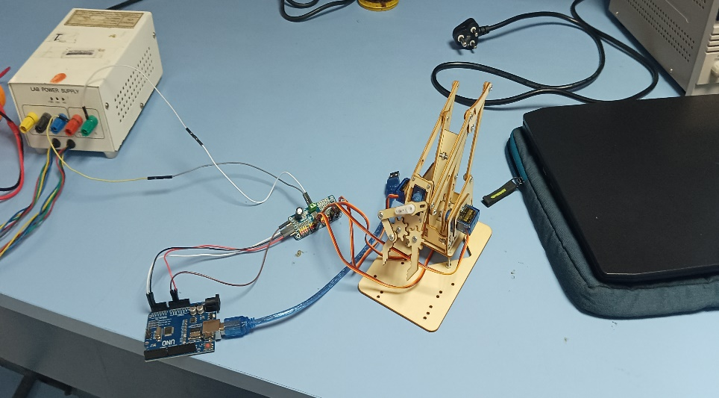 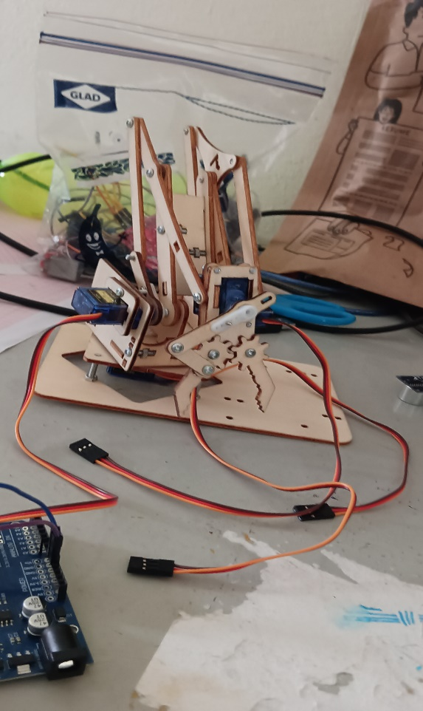

Conclusion:

The implementation of a robotic arm mounted on a wheelchair is a significant technological advancement that addresses the mobility and independence challenges faced by individuals with physical disabilities. This project aims to enhance the quality of life for users by providing them with a versatile and assistive tool capable of performing various tasks. Through the integration of a robotic arm with a wheelchair, users gain increased autonomy, enabling them to perform daily activities more efficiently and with greater ease.

The success of the project lies in its ability to seamlessly integrate with the wheelchair's existing controls, ensuring user-friendly operation.

The inclusion of sensors and advanced algorithms enhances the safety and precision of the robotic arm, preventing collisions and ensuring smooth navigation in various environments. User feedback and testing have played a crucial role in refining the system, making it more intuitive and adaptable to individual needs.

References:

1. L. Sawaqed, A. I. Al-Ali, K. S. Hatamleh and M. A. Jaradat, "Modeling and simulation of a moving robotic arm mounted on wheelchair," 2017 7th International Conference on Modeling, Simulation, and Applied Optimization (ICMSAO), Sharjah, United Arab Emirates, 2017, pp. 1-5
2. R. S. Kanash, S. E. Alavi and A. A. Abed, "Design and Implementation of Voice Controlled Robotic ARM," 2021 International Conference on Communication & Information Technology (ICICT), Basrah, Iraq, 2021, pp. 284-289
3. A. Chaudhari, K. Rao, K. Rudrawar, P. Randhavan and P. Raut, "Development of Robotic Arm Prototype," 2023 International Conference on Sustainable Computing and Data Communication Systems (ICSCDS), Erode, India, 2023, pp. 1053-1057
4. J. Wang and H. Peng, "Object Grabbing of Robotic Arm Based on OpenMV Module Positioning," 2023 2nd International Conference on Artificial Intelligence and Computer Information Technology (AICIT), Yichang, China, 2023, pp. 1-4
5. S. Rooban, I. J. S, R. Manimegalai, I. V. S. Eshwar and R. U. Mageswari, "Simulation of Pick and Place Robotic Arm using Coppeliasim," 2022 6th International Conference on Computing Methodologies and Communication (ICCMC), Erode, India, 2022, pp. 600-606
6. B. R. S, G. V. A, C. M, A. S and H. M. E, "Transhumeral Sensory System to Control Robotic Arm," 2023 IEEE International Conference on Distributed Computing, VLSI, Electrical Circuits and Robotics (DISCOVER), Mangalore, India, 2023, pp. 185-190,
7. D. Crăciun, N. Bălăceanu, A. Chirită and C. Ciobanu, "Robotic Arm Control via Hand Movements," 2022 International Symposium on Electronics and Telecommunications (ISETC), Timisoara, Romania, 2022, pp. 1-4
8. M. M. U. Saleheen, M. R. Fahad and R. Khan, "Gesture-Controlled Robotic Arm," 2023 International Conference on Computer Science, Information Technology and Engineering (ICCoSITE), Jakarta, Indonesia, 2023, pp. 495-499
9. S. Gushi, Y. Shimabukuro and H. Higa, "A Self-Feeding Assistive Robotic Arm for People with Physical Disabilities of the Extremities," 2020 5th International Conference on Intelligent Informatics and Biomedical Sciences (ICIIBMS), Okinawa, Japan, 2020, pp. 61-64
10. S. Zhang, X. Wang and Y. Shen, "Research of an Algorithm Combining Vision with Robotic Arm Grabbing," 2022 34th Chinese Control and Decision Conference (CCDC), Hefei, China, 2022, pp. 5533-5538